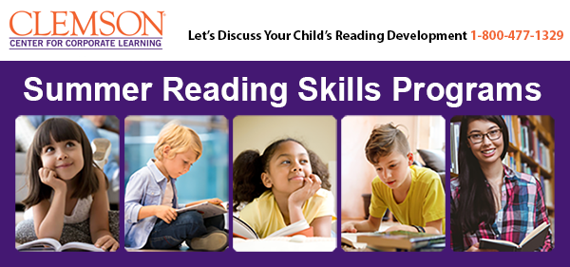

This summer, help your child become a confident, enthusiastic reader in the Summer Reading Skills Programs, offered by Clemson University's Center for Corporate Learning. Classes are taught by instructors from the Institute of Reading Development.
Strengthen Skills, Build Confidence, Enjoy Reading
These programs teach key reading skills for every grade, from phonics and sight words for younger children, to comprehension, textbook strategies and writing skills for older kids, and everything in between.
Guided by a knowledgeable and supportive teacher, students in these programs experience reading success again and again, developing their skills and building confidence in outstanding books at the right level of challenge for each age.
Your child will build the skills, confidence, and motivation he or she needs to become an avid, enthusiastic reader, who enjoys reading for school and for pleasure.
How the Programs Work
Your child will attend weekly live online classes that build skills and provide great experiences with terrific books – books that are filled with interesting characters, exciting storylines, and engaging themes. Between classes, your child will practice reading and complete fun interactive lessons that develop core skills and build confidence.
An Institute of Reading Development teacher will provide all the support and instruction your child needs to grow as a reader and student. Your child will get a jumpstart on the next school year and be ready to make it a big success!

